SH115B Insulating oil dielectric loss and resistivity tester

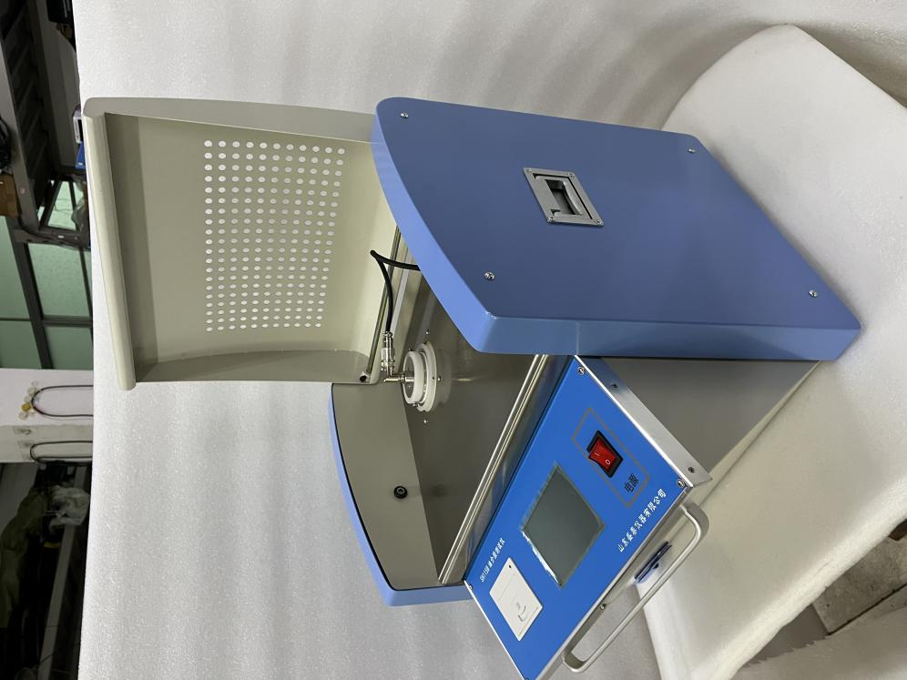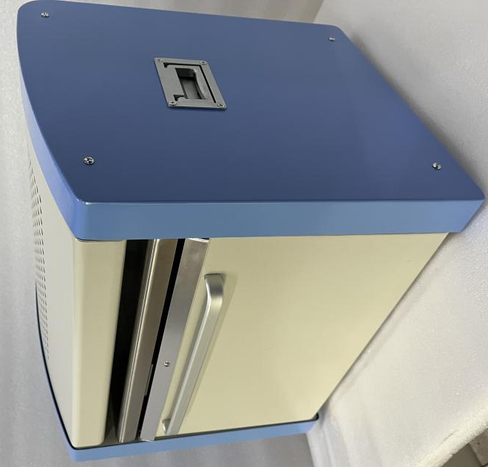

SH115B insulating oil dielectric loss and resistivity tester is a high-precision instrument with integrated structure for measuring dielectric loss angle and volume resistivity of insulating oil and other liquid insulating media.
The main components such as dielectric loss oil cup, temperature controller, temperature sensor, dielectric loss test bridge, AC test power supply, standard capacitor, megger, DC high voltage source are integrated inside.
The heating part adopts the currently advanced high-frequency induction heating method, which has the advantages of non-contact between the oil cup and the heating body, uniform heating, fast speed and convenient control. AC test power supply adopts AC-DC-AC conversion mode to effectively avoid the impact of mains voltage and frequency fluctuation on the accuracy of dielectric loss test. Even if the generator generates electricity, the instrument can operate correctly. The internal standard capacitor is SF6 gas-filled three-pole capacitor. The dielectric loss and capacitance of the capacitor are not affected by ambient temperature, humidity, etc., to ensure that the accuracy of the instrument is consistent after a long time of use, and the measurement of resistivity complies with GB/T5654.
The internal part of the instrument adopts full digital technology, all intelligent automatic measurement, multiple mode measurement, and is equipped with a large screen (320 × 240) Touch display, full Chinese menu, Chinese prompt for each step, test results can be printed out, and operators can use it skillfully without professional training.
Testing items | Integrated with major components such as dielectric loss oil cup, temperature controller, temperature sensor, dielectric loss test bridge, AC test power supply, standard capacitor, high resistance meter, DC high voltage source, etc. The heating part adopts the currently advanced high-frequency induction heating method
Compliant with standards | GB/T5654
Simple technical features or parameters | The instrument adopts fully digital technology internally, with all intelligent and automated measurements, multiple modes of measurement, and is equipped with a large screen (320 × 240) Touch screen display, full Chinese menu, with Chinese prompts for each step, test results can be printed out, and operators can proficiently use it without professional training

Technical parameters
Distance between high and low pressure | 2mm
Empty cup capacitance | 60±2PF
High test voltage | Power frequency 2000V
Empty cup dielectric loss | tgδ＜1×10-4
Liquid capacity | About 40ml
Electrode material | stainless steel
volume | 70mm(D)×120mm（H）
Conditions of use | -15℃∽40℃ RH＜80%
Electrical source | AC 220V±10% Unrestricted frequency
AC high voltage output | 400V∽2200V ±2% every100V 50VA
DC high voltage output | 200V∽600V ±2%
Temperature controlled induction furnace | The most powerful500W
Temperature control range | <100℃
Temperature control error | ±0.5℃
Resolution of temperature measurement | 0.1℃
Temperature control of time | At room temperature to90℃ Less than20min
Measuring range | tgδ  C x  R | Unlimited  15PF-300PF  10M-10T
Resolution | △ tgδ：  △ Cx ：  △ Rx ： | 0.001%  0.01pF  0.01
Fine degree | △ tgδ：  △ Cx ：  △ Rx ： | ±(reading*0.5%+0.040%)  ±(reading*0.5%+0.5PF)  ±reading * 10%
Relative dielectric constant | εr | According to the Cx Automatic calculation with the same precision Cx
Volume resistivity | ρ | According to the Rx Automatic calculation with the same precision Rx
Overall dimensions: 450×310×360mm Heavy volume:20Kg

Packing list of insulating oil dielectric loss resistivity meter
S/N | Name | Quantity | Unit | Remarks
1 | Instrument host | 1 | set
2 | Oil cup | 1 | piece
3 | Test temperature sensing wire | 1 | piece
4 | Data acquisition line | 1 | piece
5 | Inspect 2KV high-voltage test line | 1 | piece
6 | Send to test line | 1 | piece | Black/long/clip at one end/connector at one end
7 | Measuring cup | 1 | piece | 50ml
8 | Power cord | 1 | piece
9 | Instructions | 1 | copy
10 | Packing list | 1 | copy
11 | Certificate warranty card | 1 | copy

